**eg:Query the information of students.**

select * from student;

**Q1: Query the information and course scores of students whose grades in the "01" course are higher than those in the "02" course**

**Q2:** **Query the information and course scores of students whose grades in the "01" course are lower than those in the "02" course**

**Q3:** **Query the student number, student name and average score of students whose average score is greater than or equal to 60 points**

**Q4: Query the student number, name and average score of students whose average score is less than 60 points (including those with and without scores)**

**Q5: Query the student number, student name, total number of courses selected, and total grades of all courses (including those without selected courses) of all students**

**Q6: Query the number of teachers with the surname "Li"**

**Q7: Query the information of students who have studied with teacher "zhangsan"**

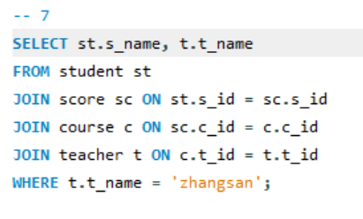

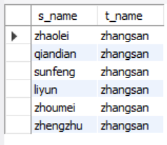

**Q8: Query the information of students who have not studied under teacher "zhangsan"**

**Q9: Query the information of students who have studied the course numbered "01" and also studied the course numbered "02"**

**Q10: Query the information of students who have studied the course numbered "01" but not the course numbered "02"**

**Q11: Query information about students who have not completed all courses**

**Q12: Query the information of students who have at least one course that is the same as the student with student number "01"**

**Q13: Query the information of other students who are studying the same course as the student numbered "01"**

**Q14: Query the names of students who have not studied any course taught by "zhangsan"**

**Q15: Query the student ID number, name and average grade of students who failed two or more courses (Even if you did not take the exam, your score will be recorded as zero, so it should be considered a failure.)**

**Q16: Query the student information of "01" course whose score is less than 60 and sorted by score in descending order**

**Q17: Displays the grades for all students in all courses and the average grade by average grade from highest to lowest (Students who did not take the exam will have a score of 0)**

**Q18: Query the highest score, lowest score and average score of each subject: displayed in the following form: course ID, course name, highest score, lowest score, average score, passing rate, medium rate, good rate, excellent rate – passing is >=60 , medium is: 70-80, good is: 80-90, excellent is: >=90**

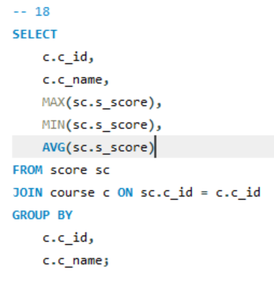

**Q19: Query the student information, Sort by the scores of each subject and display the ranking**

**Q20: Query students’ total scores and rank them**



